**Exercise 1: Control Structures – Documentation**

For this task we need a pre-defined data for which we use file named as ‘Data_Insertion.sql’.

Data Output –

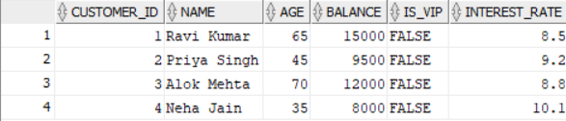

**Scenario 1: Discount for Senior Citizens**

* Objective: Reduce interest rate by 1% for customers older than 60.
* Logic: Use a loop and IF condition to identify age > 60, then UPDATE.
* The Respective Code is named as with file ‘Apply_Discount.sql’.

Output –

SELECT * FROM customers;

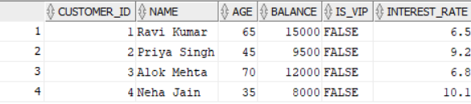

**Scenario 2: Promote to VIP**

* Objective: Set IsVIP to TRUE for customers with balance > $10,000.
* Logic: Use loop and IF condition to check balance, then UPDATE.
* The Respective Code is named as with file ‘Promote_to_VIP.sql’.

Output –

SELECT * FROM customers;

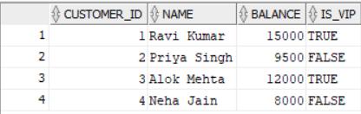

**Scenario 3: Loan Due Reminder**

* Objective: Print a reminder for loans due within 30 days.
* Logic: Join loans and customers, filter using BETWEEN SYSDATE AND SYSDATE + 30
* The Respective Code is named as with file ‘Apply_Discount.sql’.

Output –

